 | STA301- Statistics and Probability  Solved Subjective  From Midterm Papers | March 19,2012
MC100401285 | Moaaz.pk@gmail.com Mc100401285@gmail.com | PSMD01
STA301 – Midterm Fall 2012 (December)

Question ( Marks: 5 )
The numbers of airplane accidents in a year are 1, 2, 3, 4 with corresponding probabilities 1/6, 2/6, 2/6 and 1/6. What is the variance of annual accidents?
Solution:-

X | P | PX | X² | PX²
1 | 1/6 | 1/6 | 1 | 1/6
2 | 2/6 | 2/3 | 4 | 4/3
3 | 2/6 | 1 | 9 | 3
4 | 1/6 | 2/3 | 16 | 8/3
Total |  | 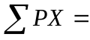5/2 |  | 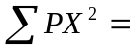43/6

VAR(X) = E(X)² - EX²
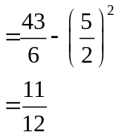

Question ( Marks: 3 )
A ball is selected at random from a bag contains 2 white, 5 black and 7 green balls. What is the probability that it is a
- White ball
- Green ball

Solution:-
White Ball = 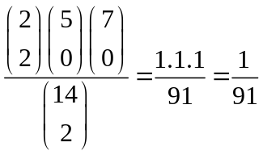
Black ball = 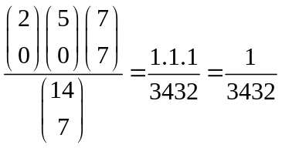

Question ( Marks: 3 )
For the given data calculate the mean deviation.
 | + 3 | - 3 | - 4 | - 1 | +1 | + 4
Solution:
X | 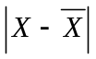
3 | 3
-3 | 3
-4 | 4
-1 | 1
1 | 1
4 | 4
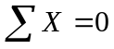 | 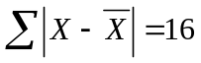

Mean = 0
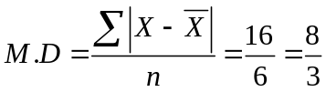

Question ( Marks: 2 )
“If P (A|B) = P (B|A) then P (A) = P (B)”.
Indicate whether the above statement is true or false? Also give reason.
Solution:-
Yes this statement is true, because
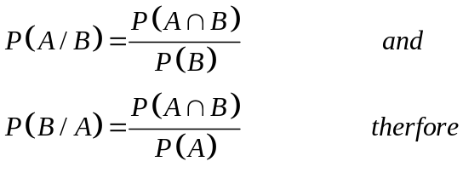
Therefore there is difference just in denominator
If the Values of P (A|B) = P (B|A re same then the denominator should also be same

Question ( Marks: 2 )
Why we use coefficient of variation?
Answer:- (Page 93)
We calculate variation if we have to compare different data with the same variable but with very different arithmetic means.

STA301 – Midterm Fall 2012 (December)

Q1: find the missing value in the formula? ( Marks: 2 )
Answer:- (Page 159)
P (B) is missing.

Q2: what is Coefficient of Correlation? ( Marks: 2 )
Answer:- (Page 128)
A numerical measure of the strength of the linear relationship between two random variables X and Y is
known as Pearson’s Product-Moment Coefficient of Correlation.

Q3: why the mean of the probability distribution of a random variable X is technically called the EXPECTED VALUE of the random variable X ? ( Marks: 3 )
Answer:- (Page 170)
Because we expect the mean from of the random variable from the data.

Q4: For the give data
Means = 3.8,
Median = 2.3 and
Standard Deviation = 1.3,
Now Find the Pearson's Coefficient of skweness ? ( Marks: 2 )
Answer:-
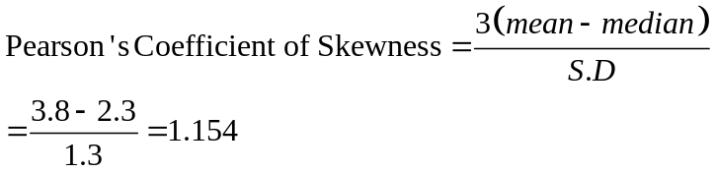
It is positively skewed

Q5: Compute the mean deviation from mean for the following data (where Mean = = 40.4)
( Marks: 5 )

X | 30 | 35 | 40 | 45 | 50
F | 4 | 7 | 11 | 8 | 5

Answer:-
X | F | , 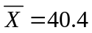 | 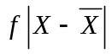
30 | 4 | 10.4 | 41.6
35 | 7 | 33.4 | 233.8
40 | 11 | 0.4 | 4.4
45 | 8 | 4.6 | 36.8
50 | 5 | 9.6 | 48
 | 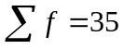 |  | 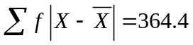

M.D = 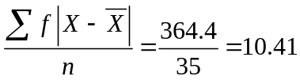

Q: A husband and wife appear in an interview for two vacancies in the same post. The probability of husband’s selection is 2/7 and probability of wife’s selection is 3/5. ( Marks: 5 )
What is the probability that
(a)Both of them will select?
(b)Only one of them is selected
(c)None of them is selected

Answer:-
Let A and B be the events if the husband’s and wife’s selection, respectively.
Given that P (A) = 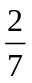 and P (B) =

(a)the probability that both of them will selected is:
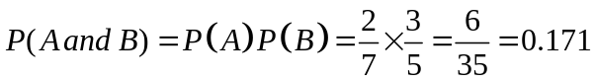

(b) The probability that only one of them will be selected is:
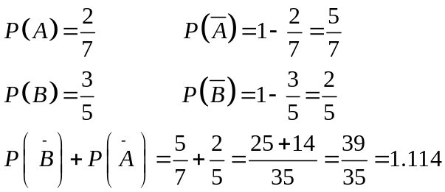

(c) The probability that none of them will be selected is:
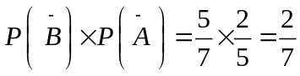

STA301 – Midterm Fall 2012 (December)

Compute the mean deviation from mean for the following data. (Where = =Mean X 18.6 )
X 14.5 16.5 18.5 20.5 22.5
Frequency 3 5 11 7 3 ( Marks: 5 )
Answer:- Rep

How the moment ratios b 1 and b 2 are helpful in determining the shape of a distribution? ( Marks: 3 )
Answer:- (Page 119)
b1 is used to determine the distribution is symmetric or not while b2 is used to determine whether the distribution is positively skewed or negatively skewed.

What are the basic properties of random experiment? ( Marks: 3 )
Answer:- (Page 145)
A random experiment has three properties:
• The experiment can be repeated, practically or theoretically, any number of times.
• The experiment always has two or more possible outcomes. An experiment that has only one possible outcome is not a random experiment.
• The outcome of each repetition is unpredictable, i.e. it has some degree of uncertainty.

Write down the principle of least squares method. ( Marks: 2 )
Answer:- (Page 122)
The principle of least squares method is to find the line of best Fit

What is the main drawback of grouping process in construction of a frequency table? ( Marks: 2 )
Answer:- (Page 147)
A frequency table has the disadvantage that the identity of individual observations is lost in grouping process.

Which two suits of playing cards are made of red color? ( Marks: 2 )
Answer:-
Heart and Diamond are of red color

STA301 – Midterm Fall 2012 (December)
1. Write the use of Venn diagram in set theory. (2 Marks)
Answer:- (Page 134)
The Venn diagrams are used to represent sets and subsets in a pictorial way and to verify the relationship among sets and subsets.

2. Can we apply Bayes theorem in the situation where partition of sample space S is created by more than two sets. (2 Marks)
Answer:-
Yes we can apply Bayes theorem in the situation where partition of sample space S is created by more than two sets.

3. Why the mean of the probability distribution of a random variable X is technically called the Expected value of the random variable X. (3 Marks)
Answer:- Rep

4. in an experiment the stiffness of a spring, the length of the spring under different loads was measured and the regression lines (X on Y and Y on X) were fitted to the model, which gave us the following results:
bxy= 0.67 and byx= 0.38 (here xy and yx are in the subscript of b)
Calculate the correlation coefficient. (3 Marks)
Answer:-
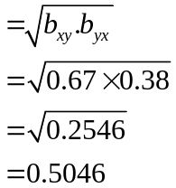

5. Assume that X is a number chosen at random from the set of integers between 1 and 14 both inclusive. What is the probability that (5 Marks)
(i) X is an even number.
Solution:-
Even = 2,4,6,8,10,12,14
P(X=even) = 7/14= ½

(ii) X is multiple of 5 or 6.
Solution:-
Multiple of 5 or 6 =5,10,6,12
Probability= 4/14 =2/7

6. Find the first two moments about mean from the following data: (5 Marks)
X= 34,70,42,54,40,68,56,38,36,72.
Solution:-

X | 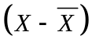 | 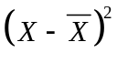
34 | -17 | 289
70 | 19 | 361
42 | -9 | 81
54 | 3 | 9
40 | -11 | 121
68 | 17 | 289
56 | 5 | 25
38 | -13 | 169
36 | -15 | 225
72 | 21 | 441
 | 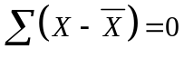 | 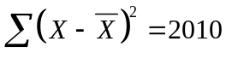

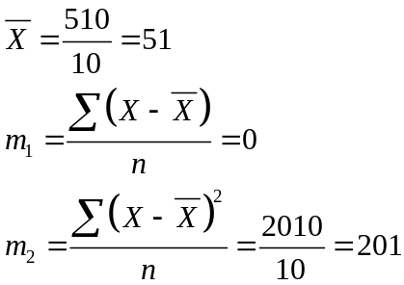

STA301 – Midterm Fall 2012 (December)

Q#2: for a data set P(A)=0.77,P(B)=0.23 and find the and. ( Marks: 2 )
Answer: 157
P (A∪B) = P (A) + P (B)
= 0.77+0.23
=1

Q#4:Find the data values, calculate person coefficient of skewness using mode of data
0.75,0.89,0.79,0.88,0.99,0.65,0.91,0.59,0.75 ( Marks: 5)
Solution:
Mean = 7.2/9=0.8 Mode = 0.75
X | X²
0.75 | 0.5625
0.8 | 0.7921
0.79 | 0.6241
0.88 | 0.7744
0.99 | 0.9801
0.65 | 0.4225
0.91 | 0.8281
0.59 | 0.3481
0.75 | 0.5625
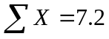 | 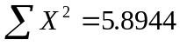

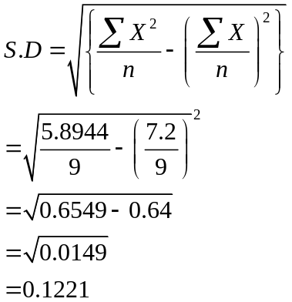

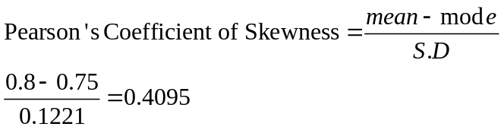

Q#5: write the two nominal equations of the regression line of X on Y. ( Marks: 2 )
Answer:- (Page 124)
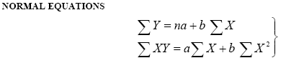

Q#6:A man tossed a fair dice and obtain the following sample space S ( Marks: 5)
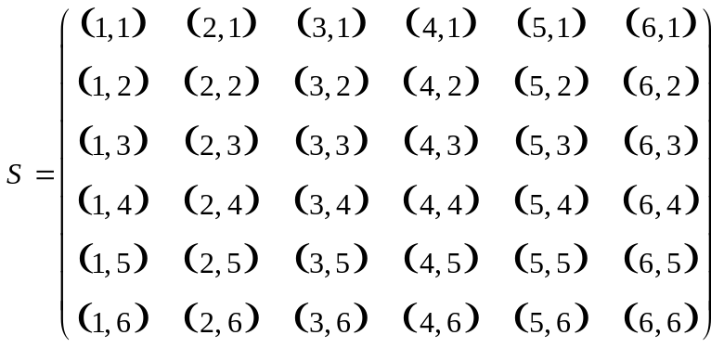
What is the conditional probability that the sum of two die will be 7 given that sum is greater then 6.

Solution:
Let A be the event that sum of 7 appears and B be the event the both dice show a number greater than 6 then,
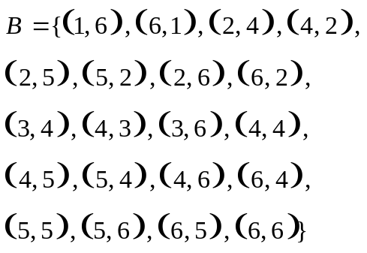

Probability= 6/36=1/6

STA301 – Midterm Fall 2012 (December)

define five number theory? ( Marks: 2 )
Answer:- (Page 97)
A five-number summary consists of X0,Q1, Median, Q3, and Xm ; It provides us quite a good idea about the shape of the distribution.

define rule of combination? ( Marks: 2 )
Answer:- (Page 143)
A combination is any subset of r objects, selected without regard to their order, from a set of n distinct objects.

chebycheves theorem inequality find karni the k=2 and k=3 limets of fraction between them btany the?
( Marks: 5 )
Answer:- (Page 94)
a) At least 1-1/22 = 3/4 will fall within 2 standard deviations of the mean, i.e. within the interval
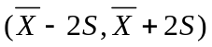

b) At least 1-1/32=8/9 of the data-values will fall within 3 standard deviations of the mean, i.e. within the interval 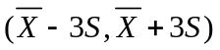

MIDTERM EXAMINATION (Spring 2012)
STA301- Statistics and Probability

Question No. 21
For which type of Data Set Empirical Rule & relationship is applied? (Marks= 2)
Answer:- (Page 94)
This is a rule of thumb that applies to data sets with frequency distributions that are mound-shaped and symmetric.

Question No. 22
If P (A\B) = 0 then A & B are independent. State is it true or false. (Marks = 2)
Answer:-
P (A/B) = P (A) and P (B/A) = P (B). It then follows that two events A and B are independent if and only if
P (A ∩ B) = P (A) P (B) and this is known as the special case of the Multiplication Theorem of Probability.

Question No. 23
X0 = 200, Xm = 500, Q3 = 350
Skewness =? (Marks = 3)
Answer:- (Page 97)
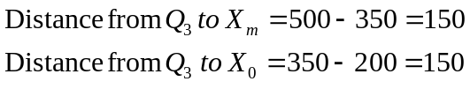
The distance from X0 to Q1 is equal to the distance from Q3 to Xm.
Therefore it is symmetric

Question No. 24
Price (X) = 59,75,27,63,27,28,56
Coefficient of Variation = ? (Marks = 3)
Answer:-

X | X²
59 | 3481
75 | 5625
27 | 729
63 | 3969
27 | 729
28 | 784
56 | 3136
Total = 335 | 18453

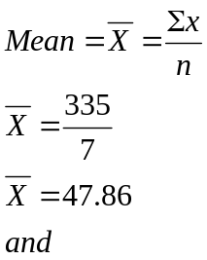
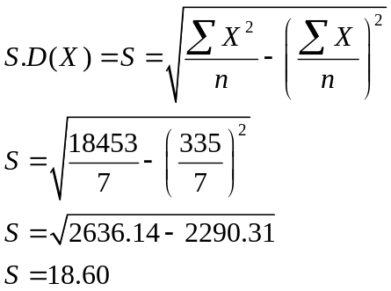

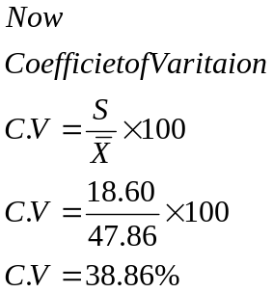

Question No. 25
Two dice are rolled, make sample space & also find the probability of Sum is 11 or greater. (Marks : 5)
Answer:- Rep

Question No. 26
Check whether distribution is probability distribution. (Marks: 5)

X | 1 | 2 | 3 | 4 | 5 | 6 | 7
P(X) | 0.15 | 0.10 | 0.20 | 0.30 | 0.25 | 0.075 | 0.025

Answer:-
TO check whether distribution is probability distribution or not
We have to find two things.
- 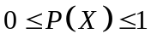
- 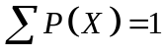
Here in Table every P(X) is less than 1 and greater than 0 therefore 1st condition is satisfied.
As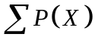is not equal to 1 therefore 2nd condition is not satisfied and it is not a probability distribution.

MIDTERM EXAMINATION (Spring 2012)
STA301- Statistics and Probability

When two coins are tossed then what is the probability that at most one head appears.
Answer:-
S = {HH,HT,TH,TT}
A = {HT,TH,TT}
n(S)= 4, n(A)= 3
P(A)= n(A) / n(S)= 3/4

2) In how many ways four books can be arranged on shelf?
Answer:-
4! =4x3x2x1 = 24

3) when two events are independent, P(A)=0.5, P(B)=0.2 then find P(AnB)=?
Solution: Page 162
P (A ∩ B) = P (A) P (B)
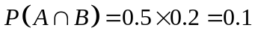

4) Define Scatter diagram?
Answer:- Click here for detail
A scatter plot is a graph made by plotting ordered pairs in a coordinate plane to show the correlation between two sets of data.

Q) when two dice are thrown then draw a sample space and find the probability of sum of both dice is 10 (5Marks)
Answer:-

Sum of 10 = 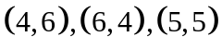
Therefore Probability = 3/36

MIDTERM EXAMINATION (Spring 2012)
STA301- Statistics and Probability

1.define sample space
Answer:- (Page 145)
A set consisting of all possible outcomes that can result from a random experiment (real or conceptual), can be defined as the sample space

2. What is scatter diagram?
Answer: Rep

4.caculat coefficient of standard deviation if x=111 123 153 173
Answer:

X | X²
111 | 12321
123 | 15129
153 | 23409
173 | 29929
560 | 80788

S.D 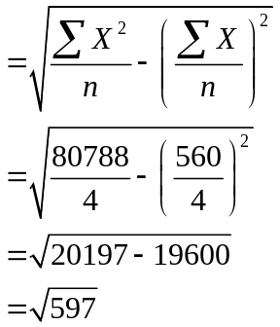

MIDTERM EXAMINATION (Spring 2011)
STA301- Statistics and Probability

Define complement of an event.(2 marks)
Answer:- (Page 146)
The event “not-A” is denoted by 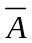 or Ac and called the negation (or complementary event) of A.

What do you know about discrete random variable?(2 marks)
Answer:- (Page 167)
Such a numerical quantity whose value is determined by the outcome of a random experiment is called a random variable. A discrete random variable is one which may take on only a countable number of distinct values

How many distinct four-digits number can be performed from the following integers 1,2,3,4,5,6 if each integer is used only once? (3 marks)
Solution:
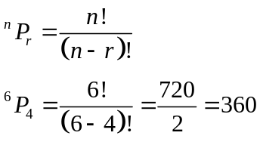

Find the coefficient of variation (C.V) for the following price of a commodity.
Price (X): 8, 13, 18, 23, 30 (5 marks)
Answer:- Rep

The following table gives the probability distribution of the random variable X, the number of foreign tours a minister make in a year. (5marks)
X | 1 | 2 | 3 | 4 | 5
P(X) | 0.1 | 0.2 | 0.3 | 0.3 | 0.1
Find the probability that:
1) Minister makes more than 2 and less than 5 tours
2) Minister makes at the most 4 tours
Answer:-
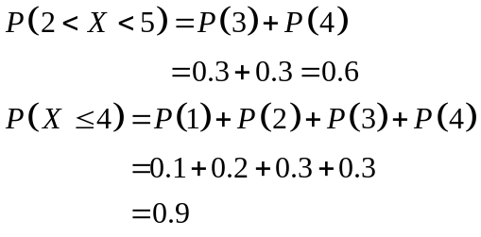

MIDTERM EXAMINATION (Spring 2011)
STA301- Statistics and Probability
1: what is average and explain it briefly
Answer: Rep
2: define random experiment
Answer: Page 167
Such a numerical quantity whose value is determined by the outcome of a random experiment is called a
random variable

MIDTERM EXAMINATION (Spring 2011)
STA301- Statistics and Probability
1- why we need to calculate coefficient of variation? (2)
Answer: Rep
2- what is the scatter diagram? (2)
Answer: Rep
3- A number X chosen at random from the integers 1 to 14 both are inclusive. find the probability
i) if x is an even number
ii) if x is an multiple of 5 or 6 (5)
Answer: Rep
4- P(A/B) = P(B/A) if P(A) = P(B) is the statment true or wrong if statment is not true then justify the reason? (3)
Answer: Rep
MIDTERM EXAMINATION (Spring 2011)
STA301- Statistics and Probability
types of averages (2)
Answer:- (Page 51)
- Arithmetic mean
- Geometric mean
- Harmonic mean
- Median
- Mode

describe least square method (2)
Answer:-
A mathematical procedure for finding the best-fitting curve to a given set of points by minimizing the sum of the squares of the offsets of the points from the curve.
is baye's theorem works on created sample space for more than two?(2)
Answer:- (Page 167)
The Bayes’ theorem can be extended to the case of two, three, four, five or more mutually exclusive and exhaustive events.
difference between absolute dispression and relative dispression (3)
Answer: Rep

if P (A intersection B) = 2/15 p(A) = 34/80 P(B) = 4/10 are they independent?(3)
Solution: A and B are independent if and only if P (A ∩ B) = P (A) P (B)
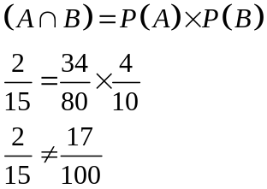

Therefore it is not independent
find co-effiecent skewness values are q3 = 39.090
q1 = 36 or 40.000
x~ = 41.00(something)
Answer:-
Bowley’s co-efficient of skewness= 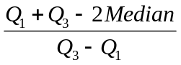 = 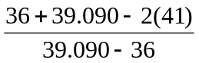
= 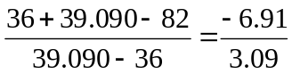

MIDTERM EXAMINATION (Spring 2011)
STA301- Statistics and Probability
1) Two properties of average? 2
Answer:- (Page 51)
- An average is a single value which is intended to represent a set of data or a distribution as a whole.
- It is more or less CENTRAL value ROUND which the observations in the set of data or distribution usually tend to cluster.

2) From a box of 52 cards is the queen and club event mutually exclusive? 2
Answer:-
No it is not mutually exclusive.

5) Find C.V for the values 16,24,24,33.
Answer:-
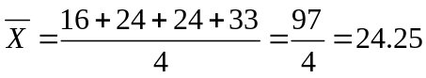
X | X²
16 | 256
24 | 576
24 | 576
33 | 1089
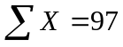 | 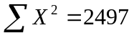
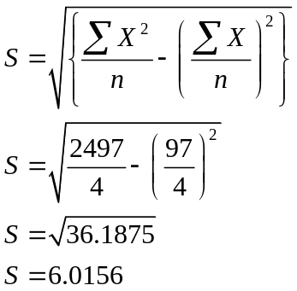
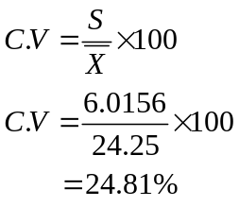
6) The probability that a student passes mathematics is 2/3 and the probability that he passes English is 4/9. If the probability of passing at least one course is 4/5, what is the probability that he will pass both courses?
Solution:- (Page 156)
P(A∪B) = P(A) + P(B) – P(A∩B)
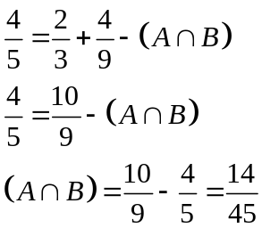

MIDTERM EXAMINATION (Spring 2011)
STA301- Statistics and Probability

What is meant by sample point 2 marks

Answer: - (Page 145)
Each possible outcome is a member of the sample space, and is called a sample point in that space.

Differ between Combination and permutation2 marks

Answer: - (Page 141)

Combination is a combination is any subset of r objects, selected without regard to their order, from a set of n distinct objects while A permutation is any ordered subset from a set of n distinct objects.

Differentiate between absolute dispersion and relative dispersion

Answer: Rep

What is dispersion 3 marks

Answer: Dispersion shows the amount of variability or spread or disperses in a set of data.

Describe descriptive and inferential statistics 3 marks

Answer:-

Descriptive Statistics: It includes all the methods and rules of statistics which helps to describe salient features of sample data

Inferential statistics: It is the branch which deals with those methods which help to infer conclusion regarding population parameter using the sample space.

MIDTERM EXAMINATION (Spring 2011)
STA301- Statistics and Probability

Define Simple and compound events 2 marks

Answer: - (Page 145)
An event that contains exactly one sample point is defined as a simple event. A compound event contains more than one sample point, and is produced by the union of simple events.

Write down the empirical relationship between Mean, Median and Mode 3 marks

Answer: - (Page 69)

Mode = 3 Median – 2 Mean

Describe Statistic, perimeter and also tell what is Classification mean? 3 marks

Answer: - (Page 6)
That science which enables us to draw conclusions about various phenomena on the basis of real data collected on sample-basis

In Equation Y = a +bx what is Y, a, b, x ? 5 marks

Answer: - (Page 121)
EQUATION OF A STRAIGHT LINE
Y = a + bX
Where
• Y represents the dependent variable
• X represents the independent variable
• a represents the Y-intercept
(i.e. the value of Y when X is equal to zero)
• b represents the slope of the line

Two coins are tossed draw a sample space 5 marks

Answer:-

S = {HH, HT, TH, TT}.

and also tell the probability of:

2 Heads

P (H=2) =1/4

At least 1 head

P (H=1) =3/4

1 tail

P (T=1) =2/4=1/2

At least 2 tails

P (T=2) =1/4

MIDTERM EXAMINATION (Spring 2010)
STA301- Statistics and Probability (Session - 4)

Question No: 21 (Marks: 2) - Please choose one
Define rule for permutation
Answer:- (Page 151)
A permutation is any ordered subset from a set of n distinct objects.

Question No: 22 (Marks: 2) - Please choose one
If mean x=0.645 and S2 =0.215
Then calculate coefficient of variation
Answer: (Page 93)
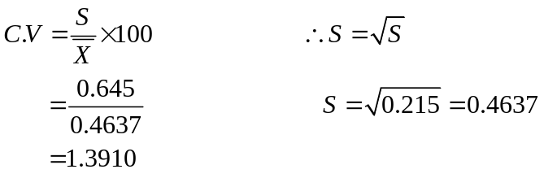

Question No: 23 (Marks: 3) - Please choose one
Find the probability of drawing white ball from bag out of 4 red, 8 blue and 3 white balls.
Answer:-
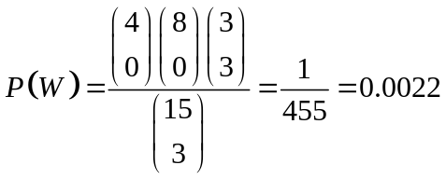

Question No: 25 (Marks: 5) - Please choose one
A and B are two independent events, if P(A)=0.40, P(B)=0.30 Find Probabilities
Answer:
- P (A∩B)
P (A ∩ B) = P (A) P (B)
P (A ∩ B) = 0.40*0.30
P (A ∩ B) = 0.12

Question No: 26 (Marks: 5) - Please choose one
If S={1,2,3,4,5,6,7,8,9,10}
And
A={1,2,3,4} , B= {3,4,5,6}
Prove that

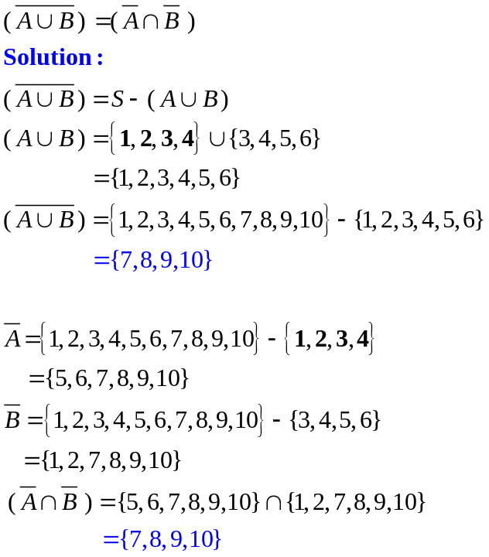

MIDTERM EXAMINATION (Spring 2010)
STA301- Statistics and Probability (Session - 4)
Question No: 21 (Marks: 2)
Why measure of central tendency and measure of dispersion are complementary to each other?
Answer: Page 51
They both deal with descriptive statistic.
Averages enable us to measure the central tendency of variable data while Measures of dispersion enable us to measure its variability.

Question No: 22 (Marks: 2)
What do you know about discrete random variable?
Answer: Rep

Question No: 23 (Marks: 3)
What is the subjective approach to the probability?
Answer: Page 149
Subjective probability is a measure of the strength of a person’s belief regarding the occurrence of an event A. Probability in this sense is purely subjective and is based on whatever evidence is available to the individual.
It has a disadvantage that two or more persons faced with the same evidence may arrive at different probabilities.

Question No: 24 (Marks: 3)
Explain the difference between absolute dispersion and relative dispersion:
Answer: Page 82
An absolute measure of dispersion is one that measures the dispersion in terms of the same units or in the square of units, as the units of the data. While relative measure of dispersion is one that is expressed in the form of a ratio, co-efficient of percentage and is independent of the units of measurement.

Question No: 25 (Marks: 5)
Differentiate between the mutually exclusive events and exhaustive events.
Answer: Page 146 & 147
Mutually Exclusive Events: Two events A and B of a single experiment are said to be mutually exclusive or disjoint if and only if they cannot both occur at the same time i.e. they have no points in common.
Example:
When we toss a coin, we get either a head or a tail, but not both at the same time. The two events head and tail are therefore mutually exclusive.

Exhaustive Events: Events are said to be collectively exhaustive, when the union of mutually exclusive events is equal to the entire sample space S.
Examples:
In the coin tossing experiment, head and tail are collectively exhaustive events.

Question No: 26 (Marks: 5)
Find the first two moments about mean from the following data.
X= 34, 70, 42, 54, 40, 68, 56, 38, 36, 72
Answer: rep

